**Quarterly Report – Public Page**

**Date of Report:** 9th Quarterly Report-January 27, 2025

**Contract Number:** 693JK32210003POTA

**Prepared for:** DOT/PHMSA

**Project Title:** Determining the Required Modifications to Safely Repurpose Existing Pipelines to Transport Pure Hydrogen and Hydrogen-Blends

**Prepared by:**  Engineering Mechanics Corporation of Columbus

**Contact Information:**  Gery Wilkowski, (gwilkows@emc-sq.com)

**For quarterly period ending:** December 31, 2024

**DOT/PHMSA TTI:** Louis G. Cardenas

# 1: Items Completed During this Quarterly Period:

The following items were delivered in this quarterly period. The total to be billed for this quarter is $49,500.

|  |  |  |  |  |  |
| --- | --- | --- | --- | --- | --- |
| Item # | Task # | Activity/Deliverable | Title | Federal Cost | Cost Share |
| 43 | 5 | Task 5 – Assess critical flaw sizes and respective detection thresholds | Critical flaw sizes and thresholds assessed | $25,000 | $20,000 |
| 44 | 6 | Task 6 – Review regulatory requirements for safety implications of pipeline conversion | Regulatory requirements for conversion reviewed | $15,000 | $0 |
| 45 | 7 | Task 7 - Determine and describe necessary operator actions | Necessary operator actions determined | $7,000 | $0 |
| 46 | 8 | 9th Quarterly Status Report | Submit 7th quarterly report | $2,500 | $0 |

# 2: Items Not Completed During this Quarterly Period:

We are on target this quarter.

# 3: Project Financial Tracking During this Quarterly Period:

The financial tracking bar graph was put on a cumulative rather than a quarterly basis. This shows that we are on track.

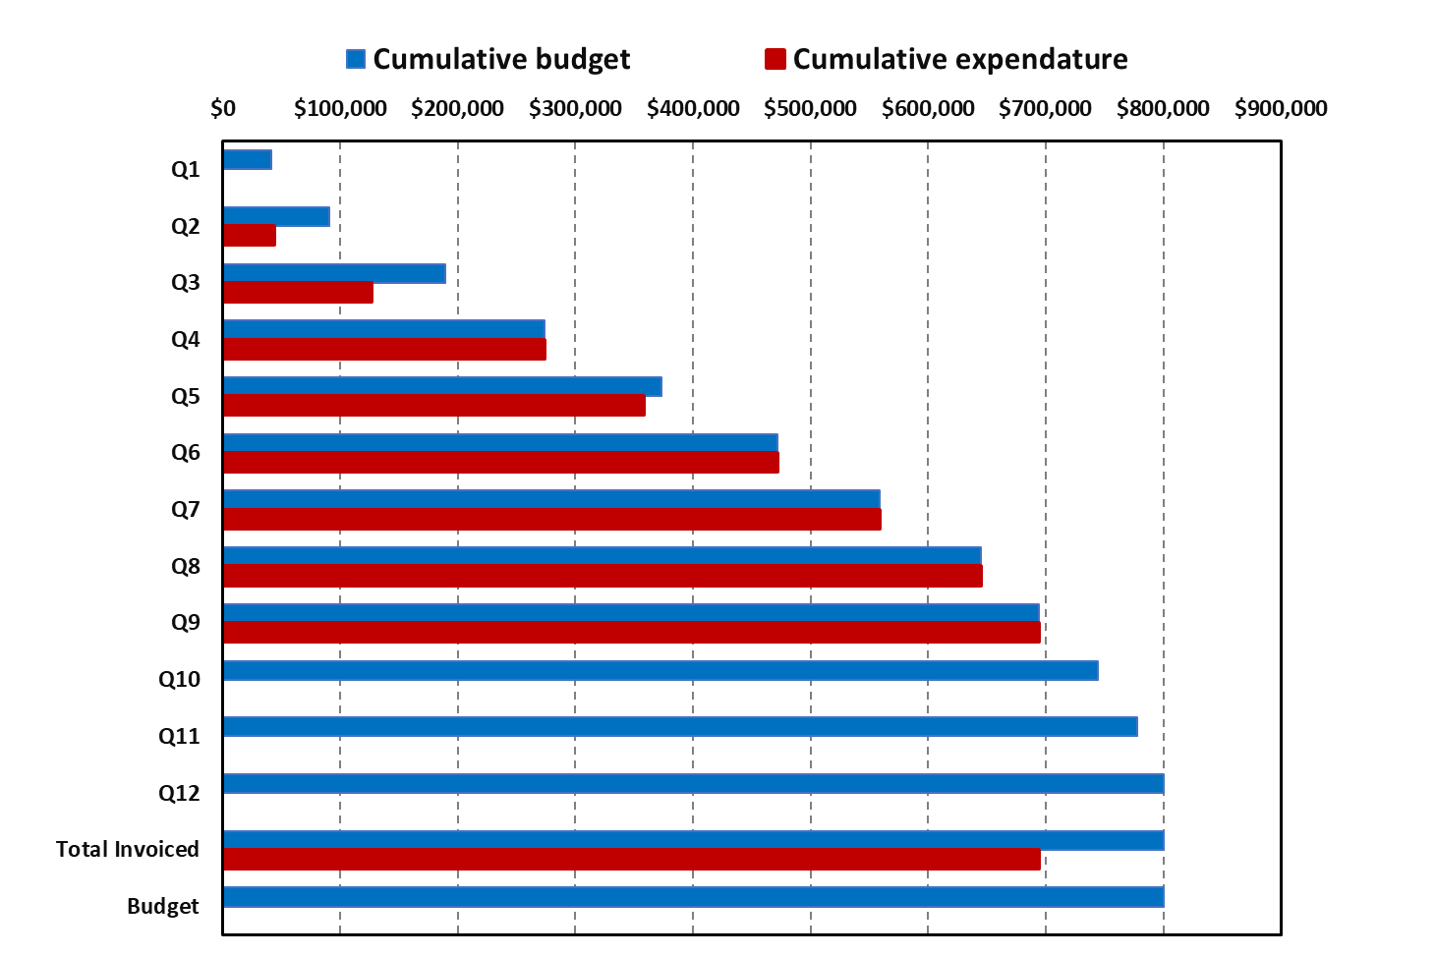

# 4: Project Technical Status

Work continued during the last quarter, as summarized below.

## Task 1 – Literature Review

Completed.

## Task 2 – Identify Potential Limitations in Components and Pipeline Conditions

Completed.

## Task 3 – Evaluate Non-Metallic Components for Retrofit or Replacement

Completed. There is nothing additional to comment on at this time.

## Task 4 – Develop Assessment and Repair Procedures for Identified Anomalies

Completed.

## Task 5 – Assess Critical Flaw Sizes and Respective Detection Thresholds

The evaluations during this time period are reported below on several different topics.

### General Commentary on Data Reduction Procedures for Determining the Fracture Toughness from Hydrogen Autoclave Tests on Slow-Strain-Rate C(T) Specimen Tests

During this quarter, a significant amount of time was spent in better understanding how the fracture toughness was determined from hydrogen autoclave C(T) specimen testing at slow strain rates. Getting this data correctly has a significant impact on all the pragmatic defect tolerance evaluations for a hydrogen pipeline fitness for purpose evaluation.

The procedure most frequently used for crack monitoring, from those with significant publications on this topic, is the direct-current electric potential method (DCEP, although sometimes abbreviated as dcEP or d-cEP), but the load and either load-line displacement of crack-mouth opening (from a clip gage) are also recorded. At Emc2, we have used the DCEP method for more than four decades in thousands of specimens and hundreds of pipe/structure fracture evaluations. We have written about 30 papers on the methodology and results that also show how the DCEP method compared to other crack monitoring methods and with test results, so we are perhaps one of the foremost groups in the world with knowledge in using this method, some references are [[1], [2], [3], [4], [5], [6], and [7]].

Reference 4 in particular provides guidance for all the different experimental aspects in obtaining high-quality DCEP data and the reduction to obtain crack initiation and growth. Some examples of DCEP versus displacement records are shown in Figure 1. Both the load versus displacement curve (black) and the DCEP versus displacement curves (multicolored) are shown. Four specific regions of the DCEP versus displacement curve are indicated in different colors. In the initial elastic loading, with good electrical isolation of the electric current going to the specimen, the DCEP voltage (using a constant-current power supply) remains unchanged. There are calibration curves that give the calibration of that voltage to the crack length for different specimens and crack geometries, as well as consideration of where the current is applied to the specimen and the location of the voltage or probe wires (see Figure 2). That calibration can be analytical, numerical, or experimentally developed. In this region, one can use that calibration for subcritical crack growth where there is no plasticity (i.e., fatigue, SCC, etc.).

However, if there is poor electrical isolation, then the DCEP in this region can be changing in a linear slope or could be very nonlinear, as illustrated by the two solid blue lines in Figure 1. The electrical isolation loss could be from the specimen not being isolated from the load frame, which depends on whether one or both sides have electrical loss and the direction of the current flow relative to the loss location. Frequently, the loss comes from current going through one or both loading pins through the clevis grip. The electrical contact changes with the Hertzian contact area of the pins on the specimen and the clevis, which is why the current changes with the load level. Once near the peak load, the contact area is reasonably constant, so this current loss might even be above the elastic region, which is not indicated in the Figure 1 schematic. The clip gage across the crack should also be electrically isolated so that current does not flow through the ends of the clip gage to the specimen contact areas.

The second part of the DCEP vs displacement curve occurs where there is blunting of the crack (brown-colored part of the DCEP versus displacement curve in Figure 1). During this time, the ligament region is plastically straining. This linear behavior happens because the *electric resistivity of all metals increases linearly with plastic strain* (a phenomenon called irreversible piezoresistivity in electromagnetic physics). One can see the electric resistivity changes with plastic strain even in tensile tests, and there are several technical publications on the change in electric resistivity with plastic strain [[8], [9], and [10]]. The DCEP across the crack is reading the electric resistance caused by the crack perturbating the electric current flow path, as well as the electric resistivity of the steel in the ligament area. The electric resistance changes due to many factors, i.e., crack size, temperature, plastic strain or hardness, microstructure, and even hydrogen content in the plastic region [[11]]). In a fracture test, the CMOD is related to the plastic strain prior to crack growth. Therefore, the DCEP across the crack changes linearly with increasing CMOD before crack growth.

From decades of work at Emc2 and dozens of technical papers by others, many researchers (including Emc2 staff) have well-documented that the onset of ductile tearing occurs once there is an increase in the electric resistivity that is greater than the “electric-potential blunting line” [4, 5, and 10]. This definition of ductile tearing initiation is consistent with multiple specimen tests [6, 10], unloading compliance [7], and a technique called the Experimental Key Curve method [8] that is the same as the ASTM E1820 Load-Normalization Method. The start of ductile tearing is pointed out by the red arrow in Figure 1. The voltage at this point is to be used as the initial voltage for the original starting crack to get the crack growth calculations.

Finally, the purple region in Figure 1 is where crack growth is caused by ductile tearing.

Figure Typical fracture testing data with good electrical isolation for the DCEP signal

Figure Typical locations for applying the voltage probe wires, which affect the voltage-crack length calibration [2]

The above background was given to understand some test results and how the interpretation of the start of crack growth can significantly change the calculated fracture toughness.

Additional background is that in slow-displacement-loading hydrogen autoclave C(T) testing, there are three aspects manifested:

1. There is primary creep which occurs even in air for line-pipe steels,
2. The slow increased loading may get to a stress level for hydrogen stress cracking (HSC) activation next, which is a *subcritical crack growth mechanism* like fatigue or SCC, and
3. Eventually, ductile tearing starts and grows, and this crack growth is used for elastic-plastic fracture toughness calculations that are used for critical flaw size evaluations.

The importance of these three aspects occurring in the same test are the following. First, the slow-loading rate lowers the fracture toughness in air, so the air test should be done at the same strain rate as the hydrogen autoclave test to see just the hydrogen effects. If just the standard ASTM E1820 standard loading rate procedure toughness data was compared to slow-displacement rate hydrogen tests with even small amounts of hydrogen, the comparison might be misleading about the amount of hydrogen affecting the toughness.

Secondly, if there is subcritical crack growth by HSC in the test, it is important to know, but the start of that subcritical cracking should not be used for the calculation of the fracture toughness. If there was subcritical HSC crack growth, that should be a function like da/dt = CKn, as was done by Shewmon [1] for high-temperature hydrogen-assisted crack growth and as done by others for different SCC mechanisms in various industries.

Finally the start of ductile tearing needs to be determined from procedures that are consistent with elastic-plastic fracture toughness. Including the subcritical HSC in the fracture toughness calculation would result in much lower toughness values that affect the critical crack size calculation. Currently, we do not see that this potential subcritical HSC crack growth rate is being determined for gaseous hydrogen exposure to steels at pipeline operating temperatures.

One of the causes for this evaluation was seeing results from an IPC2024 presentation [[12]], as shown in Figure 3. The crack initiation point seemed almost in the elastic region, and the blunting line was not indicated. The fidelity of the figure in the paper was not good enough for blunting-line determination. With the assistance of SNL staff (authors of that paper), several of their test records were received and evaluated in further detail and shared with them.

Figure Test data and crack initiation value selected from Reference 12

Figure 4 shows C(T) data from another specimen. The initiation point using the SNL method is indicated by the blue arrow. The DCEP blunting line could be examined in detail to determine the bounds of the normal electrical noise (see the red lines). The start of crack growth by the DCEP blunting line deviation.

Figure Detailed hydrogen autoclave test data from Sandia on a different line-pipe steel

In Figure 5, the test data on another C(T) specimen of line-pipe steel from Sandia National Lab (SNL) is presented (again courtesy of SNL staff). The blue arrow again shows the point where they picked the start of crack growth from the DCEP versus displacement curve, which is barely into the nonlinear region of the load-displacement curve.

In looking at the Sandia data in Figure 5 for line-pipe steel testing in an autoclave with hydrogen gas at slow displacement rates, the DCEP blunting line is defined by the scatter band of the noise, and when the DCEP increases above that scatter band, crack initiation is deemed to occur. This procedure has been done thousands of times in air tests. In this figure, the DCEP blunting line definition of crack initiation occurs at a much higher displacement than the Sandia interpretation, which will give a much higher initiation toughness than the Sandia crack initiation definition (similar to the other examples). The Sandia definition is that crack growth occurs at the first departure from the DCEP signal. This displacement is closer to the start of plasticity in the test specimen.

To demonstrate that Figure 3 and Figure 4 are not unique, Figure 5 gives the results of another hydrogen autoclave test result from SNL, comparing ductile tearing initiation definitions by their interpretation and the traditional DCEP blunting line initiation approach. Again, the *difference in the displacement at the two crack initiation points is huge*, which affects both the load at crack initiation (used for the determination of the elastic contribution of J) as well as the area under the load versus plastic-displacement curve (used for the determination of the J-plastic contribution to the J value at crack initiation).

Figure Hydrogen autoclave test data from Sandia on a linepipe steel

The difference in the crack initiation selection from the two DCEP data reduction procedures is so dramatically different that an independent validation was deemed necessary. The independent Key-Curve method (also called the Load Normalization method in ASTM E1820) for determining crack initiation can also be used with just the load-displacement data. Hence, no DCEP data are needed to validate the start of ductile tearing for elastic-plastic fracture toughness evaluations. Since this is a huge validation step, it is necessary to provide a brief summary of the Key Curve method.

The Key Curve methodology (also used in the ASTM E1820 procedure was originally developed by Dr. Jim Joyce with Dr. Paul Paris and others [[13]] and uses the fundamentals of deformation plasticity theory as is also given in the GE/EPRI Elastic-Plastic Fracture handbook [[14]] by Dr. Fong Shih and others. The Key Curve method is based on fundamental fracture mechanics theory, which says there is a unique load-displacement curve for a cracked specimen that depends on the geometry and material stress-strain curve. One can calculate the theoretical load-displacement curve for a stationary cracked specimen numerically (by FEM), analytically (i.e., using the GE/EPRI estimation procedure), or by experimental methods based on deformation plasticity (as will be shown). Once crack growth initiates, the experimental load drops below the non-growing crack curve, which defines the start of ductile fracture.

To experimentally determine the Key Curve initiation point, it is necessary to subtract the elastic displacement from the total displacement of the experimental record. That gives the load versus plastic displacement curve. Equation (1) from the GE/EPRI EPFM handbook applies to the fully plastic solution of load versus plastic displacement.

D = a eo (W-a) h4 (a/w, n, geometry) (P/Po)n (1)

where,

D = plastic displacement

a = alpha in the Ramberg-Osgood stress-strain curve; e/eo = s/E + a(s/so)n

eo = yield strain or E/so where it is generally assumed that so = sy

e = strain

s = stress

n = material strain-hardening exponent in the Ramberg-Osgood equation

h4 = geometry function (typically derived from FE analyses)

W = specimen width

a = crack length (in the C(T) specimen in this example)

Po = yield load

P = load applied

Equation (1) simplifies to the following equation for a given test on one material.

D = constant * Pn (2)

By curve fitting the plastic load-line displacement (D) versus load (P) curve and fitting it to a power law for the data prior to crack initiation, there should be a smooth, non-growing crack curve. The fitting needs to be above the proportional limit since some initial small-scale yielding takes place prior to reaching fully plastic conditions. This requires some iterative regression analyses to get the maximum number of points to achieve an R2 value better than 0.995. The region of the regression analyses can also be affected by the fact that some materials have a different strain-hardening exponent in the low-strain region than the higher-strain region of a tensile test, which requires biasing the region to the higher-displacement region to get the crack initiation point. (The varying stress-strain curve from a constant power law would not be an issue of a non-growing crack FE analysis, which was conducted for the purpose of the crack initiation point selection.) The point where the experimental load-displacement curve departs from the non-growing crack curve defines the start of crack growth to be used in an elastic-plastic fracture analysis to determine the toughness in terms of the deformation-theory J-integral toughness.

Figure 6 presents the Key Curve analysis steps for the same data shown in Figure 4. The procedure is described here to illustrate the nuances in defining the true initiation of ductile tearing (which is independent of the DCEP data for validation purposes).

The first step in Figure 6 was to subtract the elastic displacement (black line) from the experimental total displacement (gold data points). This gives the load versus plastic displacement curve, which is the green data-point curve. The proportional-limit load value is subtracted from the green curve to ease the nonlinear regression procedure in Excel, which gives the grey-dot data points. One then needs to select a region of that curve prior to crack initiation, which can be based on experience (we have done this hundreds of times) or having the DCEP blunting line evaluation as an upper limit, as in this case. The lower bounds of the regression region also need to be somewhat above the zero offset load since that initial plastic load is in the small-scale yielding region and not the fully plastic region required for the power-law fitting to work. The regression data region (brown points) was then selected to maximize the number of points and increase the statistical accuracy in the curve-fitting process (Emc2 has an ASME PVP paper on this process [[15]]). Typical R2 values usually higher than 0.995 are achieved. This nonlinear regression analysis gave the dashed yellow curve for the non-growing crack relationship in Figure 6. The experimental data drops below the non-growing crack curve at the plastic displacement corresponding to the purple arrow (from expanding the scale more than shown in this figure). One then determines the crack initiation point on the original load versus the total displacement curve, as shown by the finer-colored arrows. That initiation point is then used to calculate the J-R curve. The crack initiation point (red arrow) defined using this Experiment Key Curve process is at a slightly higher displacement than the point of deviation from the DCEP blunting-line initiation (large purple arrow), which results in a slightly higher initiation toughness. Both of those procedures for determining the start of ductile tearing result in considerably larger toughness than from the SNL DCEP new initiation criterion.

Interestingly, one can also see that the dashed yellow non-growing crack curve in Figure 6 nicely matches the experimental load-displacement curve well below and above where Sandia selected crack initiation. If crack initiation for ductile fracture toughness occurred at the SNL picked point, then there would be a deviation of the non-growing crack curve. Additionally, recall that the electrical resistance of steels changes linearly with plastic strain, so there is no indication of crack growth in the DCEP blunting region since the data are so linear in this region. If there was crack growth in the blunting line region, that region would have had the DCEP continually curving upward with displacement.

Figure Key Curve analysis of the crack initiation point for the same test data as shown in Figure 4

The C(T) specimen geometry values from the SNL tests were not provided, so to see the effect on the J‑R curve, a test conducted at Emc2 in a hydrogen autoclave was evaluated. Figure 7 shows a similar evaluation for a vintage X52 C(T) specimen tested in a hydrogen blended gas (10% hydrogen and 90% methane) at Emc2. In this case, we have all the data to show the differences between the Ji values and the J-R curves. The similar load-displacement-DCEP curves to those from the SNL tests are shown in Figure 7. In this C(T) specimen test, crack initiation selections are (a) indicated by the departure from the DCEP blunting line and (b) an arrow showing the first departure of the initial linearity of the DCEP (which seems to be more consistent with the SNL definition of the crack initiation).

Figure 8 shows the same vintage X52 data as in Figure 7 but has the detailed Key Curve procedure for the calculation of the initiation point for the start of ductile tearing for EFPM analyses of the J-R curve. The procedure is identical to that explained earlier. Figure 9 shows the Key Curve non-growing (stationary) crack curve from Figure 8 with the offset load and elastic displacement added back for direct comparison of the stationary crack load-displacement curve to the original experimental load-displacement data. *One can see that the Key Curve initiation point is very close to the DCEP blunting line definition of the start of ductile tearing, and both are at displacements much larger than the SNL procedure for the start of ductile tearing.*

Figure Detailed examination of crack initiation point in a vintage X52 C(T) hydrogen test at Emc2 at 20oC. Comparisons of new SNL DCEP crack initiation point to traditional departure from DCEP blunting line

Figure Same test data as in Figure 7, but including the Key Curve procedure for determination of the start of ductile tearing for EPFM analysis – there is reasonable agreement between DCEP blunting-line definition and Key Curve initiation points

Figure Taking the Key Curve stationary crack curve from the prior figure and adding the offset load and elastic displacements for direction comparison of the stationary crack curve to the initial experiment load-displacement test data

For this vintage X52 line-pipe base metal, the J-R curves using the deviation from the DCEP blunting-line as the initiation point and the SNL initiation point were then calculated using the ASTM E1820 eta-factor solution. The final crack length is the same in both analyses, so at the end of the test, the J values of the J-R curves must be the same at the final Da value. (The differences of the SNL J-R curve from the J-R curve using the validated crack initiation point depend on how much crack growth is in the test.) The initiation J values are, of course, quite different, i.e., the SNL initiation point results in a significantly lower Ji value using the deviation from the DCEP blunting line. In API 1176, the Ji values are frequently used for the burst-pressure calculations. From our experience in conducting stability analyses and our experimental data on surface-cracked pipes, for thin-walled pipe with a surface crack, there may only be 0.005 to 0.010 inch of stable ductile crack growth in the surface-cracked pipe, though a ductile tearing analysis is typically not performed for transmission pipeline crack analyses. So, the toughness at or near crack initiation is the most important. It should be mentioned that there are also constraint differences between a C(T) specimen and a surface-cracked pipe that can be used to estimate Ji and the J-R curve more accurately; see later discussion.

Figure Differences in Ji values and J-R curves for the vintage X52 pipe using the traditional dcEP blunting line initiation procedure and estimating the SNL initiation point

### Analysis Procedure for Critical Flaw Sizes or Burst Pressures

The following illustrates the differences in the burst pressure that would be calculated from the Ji values from Figure 10.

Since the toughness values being calculated in a hydrogen gaseous environment are in terms of the J‑integral fracture-mechanics parameter, the burst pressure analyses compatible with this fracture parameter should be used. Some are API-579 [[16]] (which is more of a failure avoidance FAD curve approach than a precise prediction of experimental behavior), CorLAS/KorLAS[[17]] (based on older analytical developments), and then MAT-8 [[18]] or the Emc2 FE-based J-estimation scheme from IPC2022 [20]. The last two are FE-based analyses, and so they provide the more fundamental definition of the crack-driving force in terms of Japplied.

For the more fundamental analyses, it should also be recognized that there are constraint differences between a C(T) specimen (used in the hydrogen autoclave testing) and the toughness of the surface crack. C(T) specimens are high-constraint specimens, while a surface-cracked pipe has a low-constraint condition. High-constraint specimens were intended to produce conservative J-R curves. The toughness of surface-cracked pipe is best simulated by the fixed-grip SEN(T) specimen, where it has been shown that for all metals, the toughness changes with the a/t of the surface crack [[19],[20],[21],[22]]. For vintage line-pipe steels, the C(T) specimen toughness (using the E1820 preferred geometry of W/B=2 and a/W from 0.45 to 0.55) is related to the SEN(T) specimen Ji value as a function of a/W as shown in Figure 11. This results in the following equation, where for thinner linepipe, the C(T) specimen (again using the preferred specimen geometry) can also be related to the Charpy upper-shelf energy as shown.

Ji-SEN(T) = 5Ji-C(T)(0.9-a/W) = 30CVP(0.9-a/W) (3)

Where,

Ji-SEN(T) = Initiation toughness in SEN(T) specimen, in-lb/in2

Ji-C(T) = Initiation toughness in C(T) specimen, in-lb/in2

a/W = crack length/width in SEN(T), or a/t in surface cracked pipe

CVP = full-size Charpy energy, ft-lb

With

JIc = 6*CVP, in-lb/in2 (4)

The above equation was established from tests on a large variety of steel in an air environment. With the higher toughness values obtained from the DCEP blunting line deviation method and the Key Curve, as discussed earlier, this trend should exist for the hydrogen environment as well. For the SNL crack initiation definition, then the J values at that “toughness” level are just barely in the non-linear region and the constraint effects may not be noticeable. (i.e., the applied loading is closer to LEFM loading where constraint does not apply as much, i.e., in fatigue crack growth constraint is not applied).

**Figure 11** Relationship of SEN(T) to C(T) toughness values with SEN(T) a/W values for ferritic steels examined and thicker TP304 steels

Since we have two Ji values in Figure 10, it is instructive to see how that changes the critical crack size. The most common size of X52 pipe was 30-inch diameter by 0.375-inch thick in the NG-18 Report 207 database, so the calculations will be for that flaw size.

The Emc2 FE-based J-estimation scheme from IPC2022 [[23]] is more precise in determining the applied J values, so it was used here. The results of the critical surface-crack pressure versus lengths are given for different surface-crack depth-to-thickness ratios (a/t). The pressure at 72% SMYS is also given as a solid black line, which is a typical Class 1 operating pressure. The critical surface-crack failure pressures nicely blend close to the unflawed-pipe burst pressure (based on ultimate strength), although the estimation procedure used the calculated stress-strain curve based on yield strength, API 5L Y/U values, and an experimental correlation from PG&E given in a 2022 IPC paper [[24]]. The critical through-wall-crack curve was calculated by the traditional LnSec equation [[25]], which used flow stress (average and yield of ultimate), so as the crack length goes to zero, it is lower than the unflawed pipe burst pressure. (With a little work that could be fixed.) The LnSec method only uses Charpy energy as a toughness input. So, the Ji values from Figure 10 were used in Equation (4) to get an equivalent full-size Charpy upper shelf energy. For the DCEP deviation from the blunting line crack initiation definition, that 244 in-lb/in2 Ji value corresponded to a CVP of 40.67 ft-lb. That is typical of vintage pipe base metals. The estimated SNL crack initiation point had the Ji value of 24 in-lb/in2, which, with Equation (4), gave an equivalent full-size Charpy energy of 4.0 ft-lb. For reference, this equivalent Charpy energy is comparable to the worst-case DC-ERW seam weld toughness found in Reference [[26]].

The results of these calculations are shown in Figure 12 for both cases. For the higher toughness case (deviation from the DCEP blunting-line definition of crack initiation, 244 in-lb/in2) are given in Figure 12(a). Note that the crack length axis is up to 20 inches and that at 72% SMYS, a surface crack with a/t < 0.275 would not fail with any length. Examination of the data points used in creating this graph showed that the curves in Figure 12(a) were adequately calculated.

For the lower toughness case (estimate of the SNL definition of crack initiation, 24 in-lb/in2) are given in Figure 12(b). First, note that the crack length axis is only up to 2 inches. Secondly, when examining the increments used in the crack length for this J-estimation procedure, the crack lengths were so short that the points for creating the J-estimation procedure would correspond to FE analyses that did not go to such short lengths[27]. Hence, the validity of the equations in the J-estimation scheme was uncertain when extrapolating to zero crack length from the shortest crack length point. Consequently, this graph gives only the calculated points and straight-line curves rather than using the Excel automated curve smoothing function. At 72% SMYS, the a/t=0.275 surface crack has a critical length of ~0.5 inches compared to more than 20 inches for the higher toughness calculations. The 0.5-inch length might be slightly shorter if valid equations for the shorter crack length existed so that a smoother curve could be created between zero crack length and the total crack length of 0.75 inches.

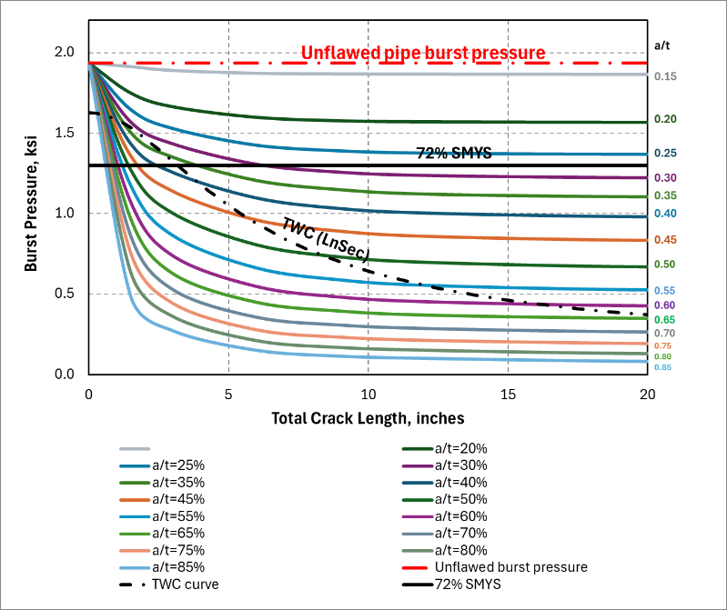

1. With Ji = 244 in-lb/in2 (DCEP blunting line) (b) With Ji = 24 in-lb/in2 (approx. of SNL procedure)

**Figure 12** Calculation of critical-surface-crack sizes for 30” by 0.375” X52 pipe with the Ji toughness values from Figure 10, using the Emc2 FE-based J-estimation procedure

The critical surface-crack size and detection ranges were explored further. The detectable crack size ranges for UMAT and ultrasonic testing crack detection (UTCD) tools were illustrated in Reference [[28]], which is repeated in Figure 13. The results from Figure 12 were used to calculate the critical surface-crack a/t and total crack-length values at 72% SMYS. The depth limits from Figure 13 for EMAT and UTCD tools were put in Figure 14. These results show that the limits from Figure 13 indicate that with the EMAT tool limits given, for the low toughness case, none of the critical surface crack conditions could be detected (one would like to detect flaws smaller than the critical crack size with some margin). However, the EMAT tool could detect the critical crack depth for the higher toughness case (using the deviation of the DCEP blunting line for the toughness calculation), but only down to lengths of 1.5 inches. The critical through-wall-crack length from Figure 12(a) is 3.5 inches, so the undetectable flaws would be leak conditions, not ruptures.

In Figure 14 it also shows that UTCD tool could detect the flaws in either toughness case. The difficulty is the UTCD tool requires a liquid coupling to the pipe during the inspection, which is good for liquid lines, but perhaps not for gaseous hydrogen lines application.

In summary, the somewhat detailed and subtle definition of the start of crack growth can have a significant impact on critical flaw sizes and detectability in service. If operating at a lower pressure, the critical flaw size curves in Figure 14 would increase, making detectability easier for the estimated low “toughness,” but might not have as significant of a change for the calculated higher toughness. For the higher toughness crack initiation procedure (using the deviation from the DCEP blunting line), the toughness in gaseous hydrogen was not much different than for operating with natural gas for the vintage steel tested. From the validating analyses (using the Key Curve method), we believe the higher toughness values are the proper toughness for critical crack size evaluations. This is a controversial point and should become more visible in a future EPRG round-robin on hydrogen gas autoclave fracture testing and data analysis.

Figure Example of tolerable flaw size for an axial OD surface crack [18]

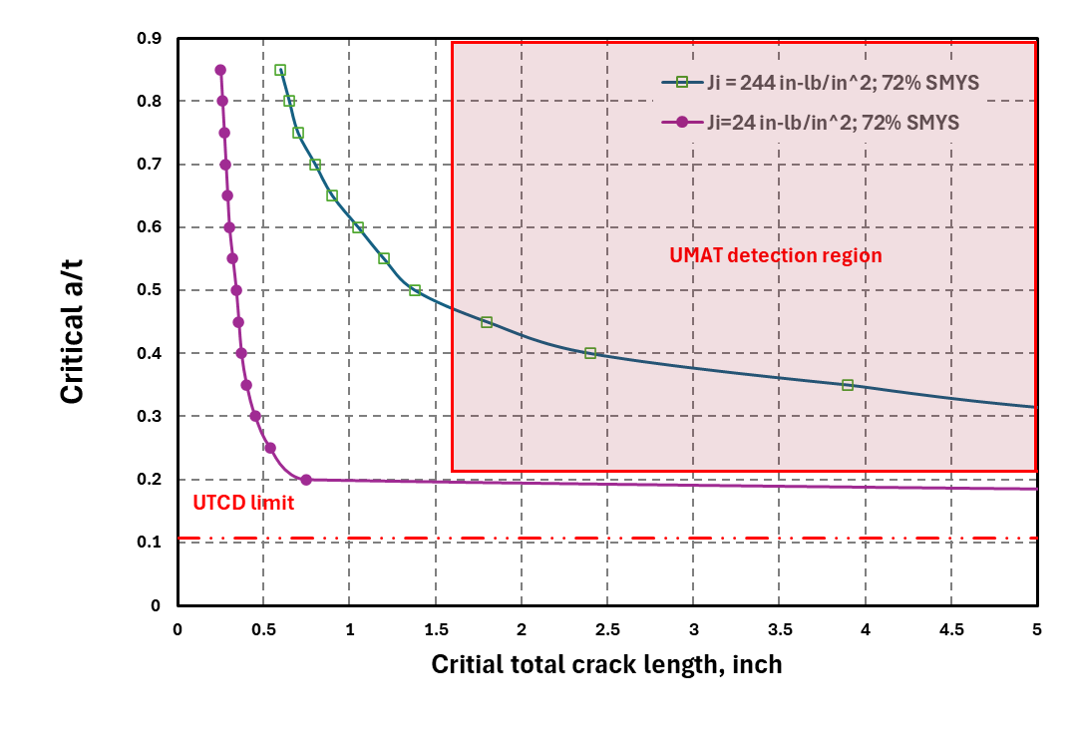

Figure Critical surface crack geometries at 72% SMYS for the 30” by 0.375” X52 pipe with the two toughness (Ji) values from Figure 10, and comparison to the detection limits shown in Figure 13

### Hard-Spot Critical-Crack-Size Evaluations for Burst Pressure

The final evaluation of critical crack sizes in this effort is for the case of hard spots in the pipe base metal. Hard spots occurred in vintage line-pipe steel more predominately around the 1950s to early 1960s. During that time period, the carbon and manganese contents of the steel plates to make the pipes were much higher [[29]]. That combination can give a much higher hardness in LF/DC-ERW and EFW fusion regions, as well as accidental plate cooling that creates hard spots in the base metal away from the seam welds.

For current pipe-line operations, hard spots can be a structural integrity concern if there is a coating loss, the soil is moist, and the applied cathodic protection (CP) may also be affected by trace elements in the soil that affect the corrosion protection. The corrosion process is on the external surface and results in hydrogen being generated on the surface. That local hydrogen, along with the higher hardness of the steel, can cause hydrogen stress cracking. The hydrogen stress crack could grow until there is a failure, although there is some evidence that the cracks in the hard spots could also be SCC cracks rather than HSC. The magnitude of the atomic hydrogen created on the surface from the corrosion process relative to the atomic hydrogen that might enter the steel from hydrogen gas transport is unclear at this time. Inquiries to experts in this field have been made, with no replies.

For a hydrogen gas transportation service pipelines, it is possible that there could be hard spots that have not had coating issues for CP-related related HSC. Such hard spots could have atomic hydrogen build up from the gaseous transportation, which brings in the concern that benign hard spots may need additional attention for a vintage pipeline to be repurposed to hydrogen service.

Hard spots can also have a hardness gradient through the thickness, although in some cases, the highest hardness might be sub-surface [28]. The hard spots are created when the steel is in plate form, so potentially, the higher hardness could be on the ID surface of the pipe. The sources of hoop stress that could cause an axial crack formation are internal pipe pressure, which is a flatter region in the hard spot from the plate-to-pipe forming process, and that flatter region has an induced bending stress when the pipe is pressurized, there are the plate-to-pipe fabrication residual stresses, and there is a thermal shrinkage/phase transformation induced-residual stresses from when the hard spot was created in the plate by the accidental cooling.

To explore the crack-driving force for a crack in a hard spot, an FE model was created with a perfectly flat region of the hard spot. (Details of the FE mesh and some results were in prior quarterly reports.) This is a bounding condition since there may be some curvature there, but that curvature is not documented in any reports we found.

The hardness of the hard spot can vary. It is highest somewhere near the central region of the hard spot on the surface and then blends to the pipe base metal hardness. It may also vary through the thickness, although most frequently, field measurements are just on a grid on the OD surface. For the initial modeling being done in this first-of-a-kind analysis, the hardness (and corresponding strength) in the entire hard spot was kept constant.

The FE model included a plate-to-pipe bending stress, that in past work [[30]] has shown that an average fabrication residual stress for non-expanded vintage pipe might be a through-thickness bending stress of 10 ksi on the OD surface and -10 ksi on the ID surface for the hoop direction. This stress contribution is detrimental to external hard-spot cracking, but can help the ID cracking concern.

The final hoop stress contribution comes from the creation of the hard spot in the plate form. This is a thermal-plastic/phase-transformation induced-residual stress. Although conceptionally, the FE computation is similar to weld residual stress analyses, one also needs to numerically account for the volumetric changes that occur from the phase transformation as a function of time and cooling. The LeBlond constitutive law can be used for doing this type of numerical simulation, but one needs the appropriate parameter for the chemical composition of the steel of interest. Furthermore, the final residual stresses would be affected by the softer/hotter base metal in the plate surrounding the hard spot when created. At high temperatures, there would also be primary creep that would change those stresses, but the duration from the creation of the hard spot to the final spray cooling of the plate is unknown. Given the computational unknowns, there was an opportunity to strain gage an actual hard spot removed from service. Those results showed that the residual stresses in that case had a peak tension values in the hoop stress direction of 22.2 ksi tension on the OD surface, while they were -22.2 ksi on the ID surface. The variation of the residual stresses took a parabolic shape from the centroid of the of the hardest spot. This parabolic variation of the hoop stress from this residual stress contribution was modeled as an initial stress condition in the FE model.

The analysis is initially looking at an external surface crack in the hard spot, since we have some interesting validation data for that case. The validation is that we had a service-removed hard spot that had a ~60-percent deep surface crack that was about 4-inches in axial length. The hardness was also mapped.

There were also some interesting results published by SNL staff at the IPC-2024[12] on the change in the fracture initiation toughness with hardness of the linepipe steel, see Figure 15. There is also a datapoint with a red star that indicates the toughness value determined by Holbrook and Cialone[11] on simulated hard spot material in vintage linepipe. The Holbrook toughness value in 60% hydrogen was about 3 times higher in terms of KJH from the IPC2024 paper value for the same hardness, but in terms of JIH that is a difference of a factor of ~11. That J-value difference is comparable to the difference we calculated from some cases between the SNL initiation toughness value using their interpretation of the start of crack growth versus the toughness from using the traditional deviation of the DCEP blunting line (see Figure 10). In air, the Holbrook data had a factor of 2 higher JIc than the hydrogen point shown in Figure 15, so they did show an effect of hydrogen, just not as much. Figure 16 shows the Holbrook and Cialone simulated hard-spot toughness data. It was interesting to note that they could develop a J-R curve with ductile tearing, i.e., there was no cleavage fracture. However, the tests in hydrogen had a very flat J-R curve so using a tearing resistance analysis would not give much load-carrying benefit.

**Figure 15 Trend of fracture initiation toughness with Vickers hardness of line-pipe steels**

(The red star point is data from Holbrook and Cialone [11] for simulated hardness in a vintage line pipe.)

**Figure 16 Holbrook and Cialone J-resistance curves for C(T) specimens from hardened X42 pipe tested in M (methane) MH (60% hydrogen and 40% methane), MHC (60-percent hydrogen with balance of methane and carbon monoxide), and MHCC (60-percent hydrogen with balance of methane, carbon monoxide, and carbon dioxide). Autoclave testing conducted at room temperature[11].**

Hence, the available surviving crack in the hard spot offers an interesting opportunity to assess the viability of these different toughness levels of a hard spot in hydrogen. The particular unfailed but axially cracked hard spot in hand has a 4-inch long axial surface crack in the hard spot that UT inspection gave the crack depth of about 70% of the thickness. The hard spot was removed from service after a hard-spot ILI tool run. The pipe was in Class I operating service (maximum 72% SMYS), and had a diameter of 36-inch by 0.440 inch in X52 material. This is the same pipe size as used in the FE hard-spot simulation. The highest measured hardness was Hv=350, where the Holbrook and SNL toughness values are given in Figure 15. The hard spot was about 6-inches in axial length although slightly longer in the circumferential length (~9 inches). The FE model used a circular hardspot of 6‑inches in diameter, which is close. The flatness of the hard spot is not known, although it is not perfectly flat. The FE model is conservative in this aspect. The hardness varies and tapers to the base metal in the real hardspot, but this FE model kept the hardness (strength) constant in the flat-spot region. The hardness variation through the thickness is unknown, so that was kept constant too.

A number of FE analyses were conducted with crack lengths of 2, 4, and 6 inches and a/t values of 0.2, 0.4, 0.6, and 0.8. For this case, the total crack length of 4 inches (half-length of 2-inches) was used to construct Figure 17. These FE results are still being reviewed, but these trends are of value here. In Figure 17, the change in the Japplied values at the center of the surface crack is given as a function of pressure. Also shown is the 915-psig pressure level that corresponds to the 72% SMYS class 1 limit for this. There are 2 different J levels pointed out in Figure 17.

1. The SNL fracture initiation KJIH values were converted to a JIH value. Remember, the SNL results are from C(T) specimen tests. Assuming the (W/B=2) for their C(T) specimens, then a 70-percent deep surface crack should have the same toughness as a plane-strain geometry C(T) specimen, see Figure 11. For the 70-percent deep surface crack in the hard spot, the JIH value would predict failure at 480 psig, but the flaw survived the 915 psig pressure with no failure.
2. The Holbrook initiation toughness value in 60-percent hydrogen C(T) specimen could be used directly for the 70-percent deep surface crack because of the constraint argument from above. That JIH values are in Figure 15. The prediction of the failure pressure is 650 psig at this toughness level, which is closer but still above the pressure that the flaw survived.

Some additional aspects that are being explored are the following.

* First, the FE model assumed a 10 ksi bending stress through the thickness, which is a typical number. However, the pipes with the cracks had measurements of that residual fabrication stress closer to 1 ksi, i.e., much smaller.
* The FE model has a perfectly flat region for the hard spot, while the actual hard spot does have some curvature to it, so this aspect of the FE model is conservative.
* We examined several circular pipe burst pressure models, but with the very high yield strength of the Hv=350 level, most of the models had difficulty. So, it is easier just to run some FE analyses with the circular pipe having the higher strength of the hard spot as a sanity check on the FE hard-spot model.
* The location of the crack might have started in the higher Hv=350 location, but the surface crack tip is probably in a lower hardness (higher toughness) region of the hardness profile through the thickness. Some through thickness measurements are in Reference [28], but that profile is unknown in this case. There may be similar hardspots removed from service that may have the through-thickness hardness data. We will try and obtain that data.
* The Holbrook non-hydrogen C(T) JIc values were about 125 to 150 in-lb/in2, which would give a higher failure pressure, although the FE model suggests that the toughness still had to be greater than 250 in-lb/in2; see Figure 18. So, this doesn’t explain the results to date.
* There are also some hard spots that fail due to subcritical hydrogen stress crack growth to the critical size, but potentially, this crack might have been due to an SCC crack. Nevertheless, it would have had some hydrogen exposure electrochemically.

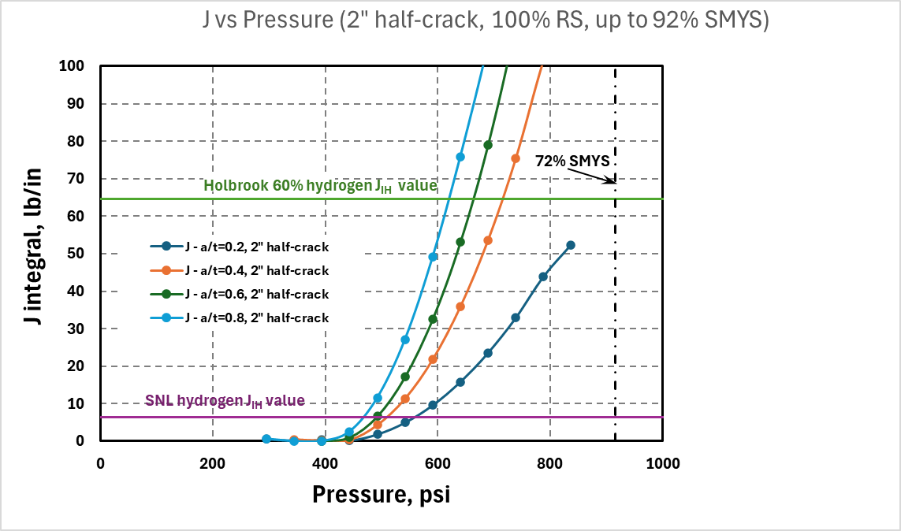

**Figure 17** FE-based crack-driving force curves for various axial surface cracks in a hard spot having 350 HV, toughness values using SNL value from Figure 15 with Hv=350, and Holbrook JIc for 350 HV from Figure 15

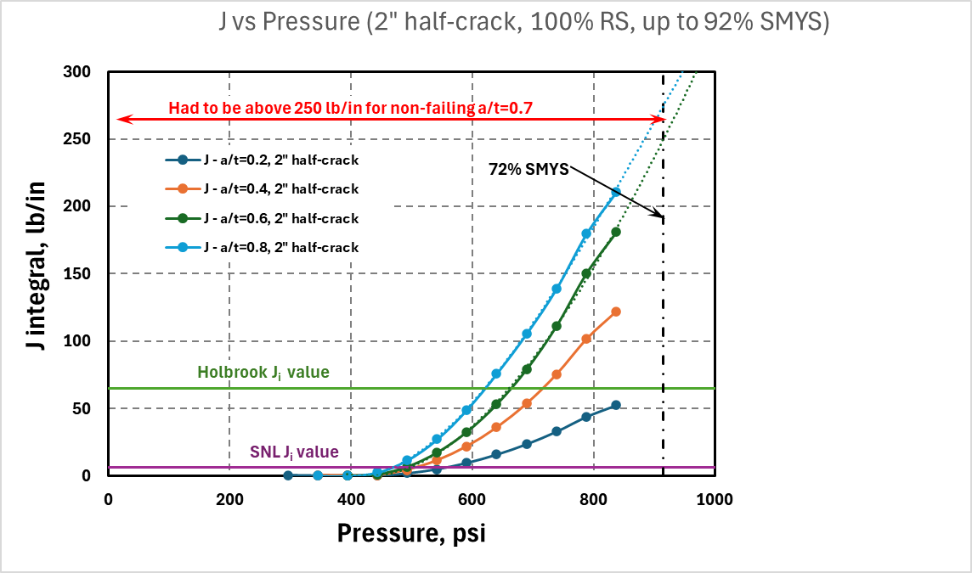

**Figure 18** FE-based crack-driving force curves for various axial surface cracks in a hard spot having 350 HV, toughness values using SNL value from Figure 15 with Hv=350, and Holbrook JIc for 350 HV from Figure 15

## Task 6 – Review Regulatory Requirements for Safety Implications of Pipeline Conversion

In Task 6, the focus is on the review of regulatory requirements/changes when repurposing pipelines to hydrogen/hydrogen blend service. In the U.S., pipelines are regulated by Title 42 Part §192 of the CFR, with enforcement and rulemaking responsibility by the Pipeline and Hazardous Materials Safety Administration (PHMSA). This regulation covers NG (natural gas) and “other gas” but does not directly address hydrogen service. It incorporates by reference B31.8S but does not include ASME B31.12. There is an ongoing activity within the ASME B31.8 committee to draft new requirements that specifically address the effects of hydrogen on mechanical integrity for new pipeline construction as well as repurposing an existing pipeline for hydrogen service. This will likely be named B31.8H. Information from the current B31.12 standard (more from the new construction viewpoint), as well as current data, are being used to develop this new standard. It is likely that once completed and published by ASME, future regulations will reference B31.8H. The EFI arm of PRCI recently prepared a “Consensus Engineering Requirements” report to document areas in which committee members are aligned. Emc2 has been following this work very closely and has performed a gap analysis between our recommendations in the recent DOT/PHMSA Project #693JK32210013POTA “Review of Integrity Threat Characterization Resulting from Hydrogen Gas Pipeline Service” project, and this report. The following provides this review.

**Review of PRCI Report on Consensus Engineering Requirements for Pipelines in Hydrogen and Hydrogen Blends Services relative to Emc2 DOT/PHMSA Hydrogen Pipeline Projects**

**Summary**

The document, referred to as Consensus Engineering Requirements (CER), was issued in August of 2024 for EFI and was written by Rosen. The main authors are Shaw, Slater, and Gallon. It is intended as an input to the development of new requirements in B31.8, and addresses *both* new design and reuse of existing pipelines. There is a statement that, *“The broader path forward shifts hydrogen content away from the standalone ASME B31.12 hydrogen standard and transfers hydrogen content to other ASME codes and standards. The hydrogen pipeline guidance is to be moved into ASME B31.8. Similarly, the power piping content for hydrogen lines is to be moved to ASME B31.1, and the hydrogen process pipeline content is to be moved to ASME B31.3.”* It is not clear what will happen to B31.12.

There were seven areas addressed, described as “work packages”:

* Design,
* Materials,
* Operations and Maintenance,
* Welding,
* Repurposing,
* General, and
* Appendices.

A gap analysis was performed between B31.12 and B31.8, and the specific elements from B31.12 essential for inclusion in the CER were identified. There is an expectation that the CER will progress through the ASME approval process, with the aim of inclusion in the 2026 version of ASME B31.8 Gas Transmission and Distribution Piping Systems to become the default standard for hydrogen transmission and distribution pipelines. Indeed, there is a B31.8 hydrogen task group that meets on a bi-weekly basis at this time to expedite that effort. Several areas have been identified that need further research prior to implementing code/standards recommendations.

The overall content of the document agrees with the essentials of the Emc2 report for DOT/PHMSA on “Reviewing of Integrity Threat Characterization Resulting from Hydrogen Gas Pipeline Service.” Trends in material properties and the need for ECA analysis prior to repurposing a line are emphasized. The only area that was emphasized slightly more was non-metallics, but this aspect was minor. The following is a summary of key items.

1. No minimum hydrogen content for defining hydrogen service is included. *“This Code covers the design, fabrication, installation, inspection, examination, and testing of pipeline used for the transportation of gas and gas-liquid mixtures including, but not limited to, fuel gas, sour gas, gaseous carbon dioxide, gaseous hydrogen, and hydrogen blends. Gaseous hydrogen in the context of this code is composed predominantly of hydrogen, without the intentional admixture of other components. Gaseous hydrogen (H2) blend: a blend of natural gas and hydrogen, where there is any intentional addition of hydrogen.”* The only hydrogen % referenced is 10%, but only for the purposes of consequence assessment. It does state that even small partial pressures of hydrogen will significantly affect properties.
   1. Although our review of some of the low concentration hydrogen work has shown that the difference between air tests at typical E1820 loading rates and low amounts of hydrogen in slow rate testing is due more to primary creep than hydrogen effects.
2. An engineering assessment (EA) is required for repurposing. While API 579 is referenced as the key standard for conducting this analysis, no changes in ECA procedures are provided other than to material properties. *“The ECA shall be performed in accordance with API 579-1 / ASME FFS-1, BS7910, the applicable rules provided in Article KD-10 of ASME BPVC, Section VIII, Division 3 or another recognized international standard.”*
   1. *API-1176 may include hydrogen effects on pipeline flaw evaluations in the future and would have other ECA criteria in it.*
3. There are some general statements around the effects of strain on hydrogen concentration that may affect some forms of damage but no specific guidelines are given.
4. Fracture toughness, defined with yet another set of nomenclature (Math), must be established using ANSI CSA CHMC1 “Test methods for evaluating material compatibility in compressed hydrogen applications - Metals” using the appropriate requirements of ASTM E1820 “Standard Test Method for Measurement of Fracture Toughness.”
   1. This point is somewhat controversial as noted in Task 4. The very start of subcritical hydrogen stress cracking may be picked up in this test, but that is not the start of ductile tearing used in E1820 for fracture toughness calculations for critical flaw size evaluations. Emc2 is starting to make that point to the PRCI/B31.8 hydrogen/EPRG groups, and it is included in our DOT/PHMSA project reports and reviews.
5. Testing procedures for crack stability under static load are not mandatory, but KD-1040 of BPVC III-3 uses ASTM E1681. However, the limitations and issues with using E1681 are noted in the areas requiring further work. So, there is some contradiction in that sense. It appears the CER authors are deferring to current approaches until a better test is adopted.
   1. The development of sustained load (HSC) crack growth prior to ductile tearing needs to be quantified better, but that is not being recognized at this time yet. A da/dt = C*Kn relationship should be established, especially for repurposing applications. E1671 seems like a good starting point and has an annex for measuring da/dt, although the smaller size of pipeline thickness specimens may require some doable specimen modifications.
6. Essentially no changes are made to repair procedures. Type B and Type A sleeves are permitted. The requirement to revisit existing repairs is needed for repurposing though.
   1. The work in the Emc2 DOT/PHMSA hydrogen pipeline project shows the fillet weld of Type B sleeves is probably more susceptible to hydrogen concentration than other pipeline integrity challenges. The Emc2 work also showed that an overlay on the fillet weld regions could mitigate the integrity concerns of the fillet weld in the Type B sleeve.
7. The CER document does refer to B31.8S to address all forms of threats, but the discussion of the influence of hydrogen on these threats is not detailed. *“Reviewing which existing integrity threats are applicable from the current integrity management plan and need further assessment under gaseous hydrogen or hydrogen blend service.”*
   1. *The initial B31.8 hydrogen document is focused on developing some procedures for what is felt to be known, but there are a lot of integrity challenges to be addressed in the future.*
8. Regarding fatigue, both FCGR testing and use of S-N approach are briefly discussed, but no change here to what Emc2 recommended, i.e., use of ASME B31.12 Code Case 220.
   1. In a separate DOT/PHMSA project (#693JK32010010POTA) at Emc2 on “Hydrostatic Retesting Optimization for Older Liquid Pipelines,” the effects of crack retardation are being quantified. For a repurposed vintage pipeline, a hydrotest may be required or done. That hydrotest could be designed from that work to extend the calculated fatigue life for decades if done right. This could be helpful for a green hydrogen line that experiences larger pressure cycles. Hydrotest may also affect the hydrogen concentration, which can be helpful for some flaw types or slightly detrimental for others, as shown in Reference [18].
9. The dent limit is specified as 2% unless evaluated and determined to be acceptable. There was no change in that limit.
   1. Emc2’s work on hydrogen accumulation in dents is helpful, but not at a stage to suggest what/if any changes might be needed. Cracks in dents seem like an obvious integrity challenge to be careful with.
10. Two categories are defined for repurpose options: low-stress and high-stress options. The low-stress option includes the lower of 30% SMYS or 26 ksi. It lists several conditions that must be satisfied to repurpose a line:
    1. Principal nominal stresses of the new service are less than the lower of 30% of SMYS or 26,000 psi.
    2. Due diligence has been undertaken to satisfy that crack growth under dynamic or cyclic loads will be negligible for the considered materials in accordance with H841.1.13 (6) (i) of the CER.
    3. Due diligence has been undertaken to satisfy that crack growth under static loads will be negligible for the considered materials; see H811.1.4(d) and Nonmandatory Appendix S‑7-3. As part of the EA, an ECA shall be conducted to confirm the pipeline is fit-for-service under the new service condition, in accordance with para. H841.1.13 of the CER. The inputs for materials properties and anomalies used for the ECA shall represent the full range of material populations (line pipe and construction welds) and anomalies present on the pipeline. No specific testing in gaseous hydrogen and hydrogen blends is required for the low-stress option. However, the material properties shall be used and documented based on an appropriate understanding of the influence of gaseous hydrogen on materials.
       1. If the less than 30% SMYS service has large cyclic pressures, perhaps the concern of fatigue crack growth enhancement should be a warning.
11. For the high-stress option, testing is basically required to establish material properties.
12. Hard spots are not specially addressed or singled out in the document.
13. Several impacts on non-metallics (elastomers) are noted that are related to seals: stiffening, swelling and warping, and stable crack growth. No details are given though.
14. The “Battelle Two Curve” method is still recommended for crack arrest – which is applicable for propagating ductile fracture, but not if there is a propagating brittle fracture.
    1. Propagating brittle fracture might be a concern for vintage liquid lines being repurposed for high-energy service. For a 100% hydrogen line, brittle fracture arrest is easier to achieve because of the very high acoustic velocity of hydrogen. A procedure can be developed for that evaluation.
    2. For new pipeline construction, there is significant data showing that the API 5L3 pressed-notch DWTT non-conservatively gives a lower brittle-to-ductile transition temperature than full-scale burst tests. This happens for steels with CVP > 215J, which is most steels being made now. The API 5L3 standard is several decades behind in staying up with new pipeline material behavior.
15. Section S-702, page 69, addresses fracture toughness testing.
    1. Use of E1681 bolt-loaded C(T) may be limited due to the requirement to meet small-scale yielding conditions. We would certainly agree with this statement, given the size of the specimens extracted from pipelines. However, some modification to bolt loading of the C(T) test might be possible, i.e., wedge-opening of pinned specimens might be applicable.
    2. E1820 is referenced as the general approach with modifications, e.g., slow loading and all the issues associated with testing an autoclave.
    3. Only C(T) or SEN(B) specimens should be used due to uncertainties associated with test data from low constraint specimen geometries, i.e., SEN(T).
       1. In many past hydrogen autoclave tests, the C(T) specimens have been non-standard, i.e., instead of using W/B=2 many specimens have been up to W/B=7. The higher W/B values can increase the measured toughness by a factor of 2. So, the standard plane strain E1820 recommended C(T) geometry should be used in the baseline testing for getting a reference toughness that could be consistently corrected to low-constraint specimens.
    4. A minimum thickness of 5 mm is required, with specimen crack in axial direction. Interestingly, it does not reference the validity criteria already in E1820 to obtain a valid J. Again, the 5 mm thickness should be reflected in keeping W/B=2. The thickness should be maximized since that reflects the brittle to ductile transition better. C(T) specimens give a lower brittle-to-ductile transition temperature than lower constraint SEN(T) specimens or surface-cracked pipe.
       1. Most autoclave testing is only at room temperature. For base metals, that is probably sufficient; see PRCI IM-1-8 Report #1. For welds, primarily vintage welds, some might behave more brittle at operating temperatures, so testing at lower than room temperatures in an autoclave might be warranted. This is not easy to do, but it is possible.
    5. The effects of oxygen are noted but it states that pretreatment is unnecessary in the rising displacement test since the oxide layer will break down rapidly at the tip of the fatigue pre-crack. They also state that fatigue pre-cracking does not have to be done in hydrogen.
       1. The premise in the above statement is that the hydrogen entry is from the freshly exposed new surface. However, molecular hydrogen can be adsorbed into the steel around the whole surface of the specimen. That hydrogen will want to be transported and trapped near the crack tip region with higher hydrostatic stress and plastic strain trapping sites. So the pretreatment in hydrogen can be beneficial in conducting the tests.
    6. Loading rate is recommended to be done at 0.1 MPa-√m/min and 1 MPa-√m/min, and emphasizes the importance of doing this at low hydrogen partial pressures.
       1. This is a nice procedure to try and maintain hydrogen transport and damage the crack tip. However, for a surface crack in a pipe, as the crack reaches the instability condition, the loading rate is increased since the cracked pipe is in a load-controlled fracture process not displacement controlled. So the constant displacement rate will give a conservative hydrogen damage behavior compared to a constant load loading rate.
    7. Acceptance criterion is “based on the convergence of the inferred initiation fracture toughness J values at a defined amount of crack extension.”
    8. Crack growth should be measured by DCPD. Unloading compliance is not forbidden but discouraged due to potential issues with reverse plasticity. Also, unloading compliance cannot measure the point of initiation.
       1. An alternative method called the Key Curve can independently determine the start of ductile tearing from just the load-displacement data. This would give toughness values consistent with determining fracture toughness for critical crack size evaluations. See detailed examples in Task 4.
    9. There is a fairly lengthy discussion starting on page 72 that discusses test interpretation. They recommend determining Ji (they call it Jth) or J at 0.2mm, or “something else appropriate”. This discussion was very vague and unhelpful. They reference work by CSA CHMC-1 who they say are re-examining the proper definition. In this DOT/PHMSA project, we will follow up with them to make sure they are aware of the fracture initiation interpretations as given in Task 4 of this report.
       1. There seems to be considerable confusion between fracture toughness values for critical flaw size evaluations versus the first amount of potential subcritical hydrogen stress cracking. See our extended discussion in Task 4.
    10. Regarding the time-dependent crack growth limit, which they do not refer to as KIH directly, they simply state that no in-service incidents have been reported by industry below 36 ksi-√in. It would be very useful to know the technical basis.

**Conclusions from the Comparison**

Our impression was that the document is consistent with our understanding and many of our recommendations made in the Emc2 PHMSA studies. Some key differences are: (1) the interpretation of autoclave test data to calculate a fracture toughness needs to be consistent with EPFM procedures for toughness values to be used for critical crack size evaluations, (2) the development of subcritical hydrogen stress cracking (under sustained loading) seems to be missing although evidence of it is somewhat captured by the autoclave testing prior to the start of tearing for elastic-plastic fracture toughness evaluations to be used for critical crack evaluations. Furthermore, a test procedure to get da/dt for subcritical crack growth and that data in gaseous hydrogen at operating temperatures are still needed. The main point relates to the standardization of testing methods, and here other than a few general considerations that we think everyone agrees with that need, the main issues in those test procedures are not addressed. The document does go into a fair amount of information not related to the DOT/PHMSA work at Emc2 – probably since our first report was after they had authored their report. The DOT/PHMSA hydrotest optimization work is yet even newer with the draft final report to be submitted in March 2025. They include welding procedures and general pipeline-related design. There is very little new here or particularly helpful for someone repurposing a line. There is still a large gap here in terms of providing information on how to repurpose a line. Only generalities are given in the document.

## Task 7 – Determine and Describe Necessary Operator Actions

With the introduction of hydrogen, reassessment of threats and modification of the integrity management plan will be required. ASME B31.8S provides guidance for operators on damage mechanisms and outlines the approach for operators to address them. However, it does not address the adverse effects of hydrogen. Shown in the table below are the various root causes identified in B31.8S and the implications of hydrogen blending. Operator actions, documented in their integrity management plans (IMP), must be updated to address the effects of hydrogen on material properties.

Table Impact of Hydrogen on ASME B31.8S Root Causes

|  |  |  |  |  |
| --- | --- | --- | --- | --- |
| **B31.8S Root Cause** | **Threat Level** | **Description** | **Primary Concern** | **Mitigation Approach** |
| Seam Crack | High | Cracks located in ERW seams are often associated with pipe manufacture, e.g., hook cracks and lack of fusion. Susceptible to subcritical crack growth depending on applied stress and crack size. | Crack growth to critical size, causing leak or rupture. Affected by fatigue | ILI tools such as UTCD, EMAT, or hydrotesting are used to identify and estimate size. ECA is based on fracture mechanics analysis to determine mitigation strategy. Hydrotesting can establish maximum survivable flaw to help validate ILI results. |
| Hard Spot | High | High degree of sensitivity to hydrogen. History of cracking due to hydrogen. Susceptible to subcritical crack growth depending on applied stress and crack size. | Depending on size of hard spot, HSC could result in a critical sized flaw leading to longitudinal rupture. | Detection by ILI tools is the primary approach, followed by removal. Concern for reliability of detecting hard seams due to the small volume of material affected. Are closely associated with manufacturer (primarily A.O. Smith, but also a few other manufactures of pipe in the 1950’s). |
| Wrinkle Bend | Medium | Location of high strain and complex stress state. Location that could have higher hardness due to work hardening and greater sensitivity to hydrogen. | Crack initiation and grow by fatigue leading to circumferential leak or rupture. | Identification and characterization of deformation. ECA limits may be based on dimensions, finite element analysis, estimation of strain, and assessment of fatigue life. |
| Fabrication Welds | Medium | Weld related defect density is likely compared to ERW seams. Flaws oriented normal to principal stress, but crack driving force from weld residual stress present. Lower driving force for fatigue crack growth. | Crack growth to critical size. Low driving force for fatigue crack growth. Better properties and fewer weld related defects compared to seam welds. Failure likely circumferential, leak or rupture. | Identification by ILI tools such as EMAT or UT tools designed with probes detect cracks in the circumferential orientation. |
| Nonmetallic Materials | Medium-Low | Degradation of seals/packing in valves, meters and various fittings or components. | Likely failure mode is a leak. Primarily only non-pressure boundary materials effected. | Identifying and retrofitting certain components with appropriate materials. |

# 5: Project Schedule

The GANTT chart for the project below was updated from the prior quarterly report. The efforts are on schedule.



**References**

1. [] Wilkowski, G. M., Olson, R. J., and Scott, P. M., “State-of-the-Art Report on Piping Fracture Mechanics,” U.S. Nuclear Regulatory Commission report NUREG/CR-6540, BMI-2196, February 1998.
2. [] G. M. Wilkowski, J.O. Wambaugh and K. Prabhat, “Single Specimen J-Resistance Curve Evaluations Using the Direct-Current Electric Potential Method and a Computerized Data Acquisition System,” *ASTM 15th National Symposium on Fracture Mechanics*, ASTM STP 833, June 1982, pp. 553-576.
3. [] G. M. Wilkowski and W. A. Maxey, “Applications of the Electric Potential Method for Measuring Crack Growth in Specimens, Flawed Pipes, and Pressure Vessels,” *ASTM 14th National Symposium on Fracture Mechanics*, Los Angeles, California, ASTM STP 791, June 30, 1981.
4. [] Wilkowski, G. M., Shim, D.-J., Kalyanam, S., Wall, G., Mincer, P., Rider, D., Brust F. W., and Rudland, D. L., “Using d-c Electric Potential for Crack Initiation/Growth Monitoring during Testing of Weld Metal Fracture Specimens,” *2009 Pipeline Technology Conference*, Belgium, October 2009.
5. [] Y. Hioe, S. Kalyanam, and G. M. Wilkowski, “Comparison of Calculated Crack Growth Values Using Unloading Compliance and d-c EP during SENT Testing,” paper # IPC2016- 64630, *Proceedings of the International Pipeline Conference 2016*, September 26 - 30, 2016.
6. [] S. Pothana, G. Wilkowski, S. Kalyanam, J.K. Hong, C.J. Sallaberry, “Determination of Crack-Initiation in Fracture Toughness Testing Using an Experimental Key-Curve Methodology,” PVP2021-61812, *ASME 2021 Pressure Vessels & Piping Conference*, July 12-16, 2021.
7. [] Y. Hioe, S. Kalyanam, G. Wilkowski, F.W. Brust, and E. Punch, “Direct-Current Electric Potential (d-c EP) Technique Validation Through an Experimental and Computational Study on Pipe with a Surface Crack,” *Proceedings of the ASME 2019 Pressure Vessels & Piping Conference*, paper # PVP2019-93771, July 2019.
8. [] D. Dominguez and I. Sevostianov, “Cross-Property Connection Between Work-Hardening Coefficient and Electrical Resistivity of Stainless Steel During Plastic Deformation,” *International Journal of Fracture* (2011) 167:281–287.
9. [] Brown, R.A. (1977) “Electrical Resistivity of Dislocations in Metals,” *J. Phys. F: Metal Phys*, 7, 1283-1295.
10. [] Karolik, A.S. and Luhvich, A. A. (1994), “Calculation of Electrical Resistivity Produced by Dislocations and Grain Boundaries in Metals,” *J. Phys*: 6, 873-886.
11. [] J. Holbrook and H. Cialone, “Effects of SNG/Hydrogen Gas Mixtures on High Pressure Pipelines: NG-18 Report No. 151,” Battelle Columbus Laboratory, Columbus, 1985.
12. [] Ronevich J. Agnani M., Gagliano M., Parker J., and San Marchi C., “Influence of Hardness on Hydrogen-Assisted Fracture in Pipeline Steels,” *IPC 2024*, paper IPC IPC2024-133937, September 2024.
13. [] J. Joyce, H. Ernst, and P. Paris, “Direct Evaluation of J-Resistance Curves from Load Displacement Records,” in *Fracture Mechanics*, ed. P. Paris (West Conshohocken, PA: ASTM International, 1980), 222-236.
14. [] Kumar, V., and others, “An Engineering Approach for Elastic-Plastic Fracture Analysis,” EPRI Report NP-1931, July 1981.
15. [] Pothana, S. Wilkowski, G., Kalyanam, S., Hong, J.-K., and Sallaberry, C. J. “Determination of Crack-Initiation in Fracture Toughness Testing Using an Experimental Key-Curve Methodology,” PVP2021-61812, *ASME 2021 Pressure Vessels & Piping Conference*, July 12-16, 2021.
16. [] API 579-1/ASME FFS-1, “Fitness for Service,” New York, ASME, *API 579-1/ASME FFS-1- Fitness-for-Service*, API Recommended Practice, June 2016.
17. [] Lamborn, L. Kwok, E., Polasik, S. J., Hanna, B., ASME PVP Conference, *2023 ASME PVP Conference*, Paper 2023-105832.
18. [] Anderson, T.L., “Development of a Modern Assessment Method for Longitudinal Seam Weld Cracks,” PRCI Catalog No. PR-460-134506-R01, Pipeline Research Council Inc., 2015.
19. [] Hioe, Y., et al. “Fracture Toughness Variation with Flaw Depth in Various Specimen Geometries and Role of Constraint in Material Fracture Resistance,” paper # PVP2017-65441, July 16-20, 2017, *Proceedings of the ASME 2017 Pressure Vessels & Piping Conference*.
20. [] Wilkowski, G., Kalyanam, S., Hioe, Y., Brust, F. W., Pothana, S., Uddin, M., and Orth, F., “Constraint Effects of Surface Crack Depth on Toughness – Experimental and Numerical Assessments,” *Proceedings of the ASME 2019 Pressure Vessels & Piping Conference*.
21. [] Kalyanam, S., et al., “Role of Constraint in Specimen Geometries When Evaluating Fracture Toughness/Material Fracture Resistance in a Surface-Flawed Elbow,” paper #PVP2019-93732, *Proceedings of the ASME 2019 Pressure Vessels & Piping Conference*.
22. [] Liu, Z., Wang, X., Zhang, Z., Jin, P., and Chen, X., “Solutions and Applications of 3D Elastic–Plastic Constraint Parameters for Clamped Single Edge Notched Tension (SENT) Specimens,” *Engineering Fracture Mechanics*, vol. 272, no. 108713, 2022.
23. [] Wilkowski, G., Hong, J.-K., Brust, F. W., Hioe, Y., “An Improved Axial Surface Crack Model to Predict Crack Growth and Burst Pressures Based on FE Analyses for Jplastic and J-R Curve Methodology,” paper #IPC2022- 86904, *14th International Pipeline Conference*, September 26-30, 2022.
24. [] Brady, E., Kornuta, J., Anderson, J., Steiner, A., Veloo, P., “Improvements to Strain Hardening Exponent and the Implications to Failure Pressure Predictions,” paper IPC2022-86041, *14th International Pipeline Conference*, 2022.
25. [] Kiefner, J. F. “Fracture Initiation,” paper # G, November 1969, *Symposium in Line Pipe Research*, Pipeline Research Committee of American Gas Association.
26. [] Wilkowski, G. M., Kurth-Twombly, E., Kurth, R., Bagnoli K., and Sallaberry, C., “Pragmatic Application of MegaRule RIN - 192.712 Toughness Values,” PRCI, 2023.
27. Both the Emc2 FE-based J-estimation procedure and the MAT-8 procedure had FE analyze that had a minimum thickness to half crack length t/c of 0.5, i.e., the shortest crack length case. So this shortest crack length validity concern is a common limitation for both analyses using this unusual very low toughness calculation.
28. [] Bagnoli, K., Wilkowski, G., Twombly, E., Punch, E., Hill, L., and Krishnaswamy, P., “Review of Integrity Threat Characterization Resulting from Hydrogen Gas Pipeline Service,” DOT/PHMSA Project 693JK32210013POTA, Final Report, November 25, 2024.
29. [] Rosenfeld, M., Slater, S., Nestleroth B., and Wilkowski, G., “Hard Spot Susceptibility Review ‐ Pipe Manufacturers, Pipe Type, Vintage,” PRCI, Catalog No. PR727-234502-R01, Arlington, VA, 2024.
30. [] Kiefner, J. F., Maxey, W. A., Wilkowski, G. M., and Eiber, R. J., “The Magnitude and Effects of Residual Stress in Line Pipe,” presented at the *1977 AIME Mechanical Working Conference*, January 26-27, 1977, Pittsburgh, Pennsylvania.